

# South Northants Link

Main Report

**Contents**

1. Why Northamptonshire needs it
   1. Non-stop on the existing lines
   2. To improve its economy
   3. To improve its infrastructure
   4. To reconnect nearby towns
   5. To connect the surrounding counties
   6. A link to the West Coast Main Line
2. Environment
   1. Getting cars off the road
   2. The UK net-zero 2050 promise
   3. Sustainable transport to our stations
3. Misc.
   1. Issues with our existing infrastructure
   2. Daventry-sized towns with rail links
4. A solution
   1. Heavy rail
   2. Light rail
   3. Tram-train
   4. Bus rapid transit



# Why Northamptonshire needs it

## 1a: Non-stop on the existing lines

Now, most of Northamptonshire’s railway lines are Intercity based, such as the West Coast Main Line, Chiltern Main Line and Midland Main Line, only a handful of our lines allow stopping services without causing disruption, and even these stations on these lines are rare in Northamptonshire.

Building a new link dedicated to stopping services would be a game-changer in Northamptonshire, especially in Daventry and South Northants, where there are only 2 train stations across the two districts, that is one each, and in certain areas of the district, bad bus links. Allowing space on the link (not building too many stations/stops) would also allow expansion in the future and allow new settlements to be built on the route and stations to be opened, such as in Ebbsfleet Valley and Swanscombe in the South East of the UK. These days, places need to have sustainable transport at the forefront of building new settlements, instead of having it as an afterthought. As well as this, building a separate link would mean even if trains/vehicles stopped tens of times, it would not clog up the entire system, unlike the West Coast Main Line, where there are no stations in the Northamptonshire area. This is the issue with the Weedon Station Project now, congestion all the way along the line. This issue would be eliminated with this new line.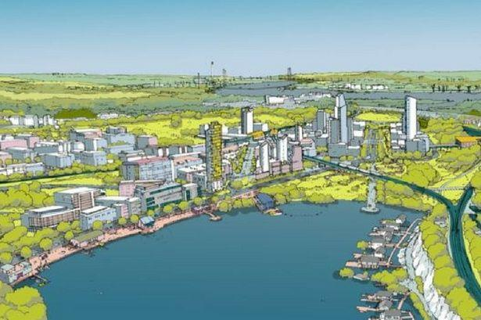

Adding to this, if something went wrong on the line such as a signalling failure, it would not affect the network nationally, only on a local level through 3 districts.

## 1b: To improve its economy

This project would be a massive win for the economy in Northamptonshire, especially in rural areas which would finally get a link to a better transport network, and therefore a link to London, Birmingham, Liverpool and more.

It would mean more people can go out and get a job in a city, while staying local to Northamptonshire, while still paying taxes in Northamptonshire, and coming home with a massive pay check from massive cities to spend on ourlocal goods, to improve oureconomy.

As well as this, people can live in small villages such as Whittlebury and Silverstone, while working in Northampton, Daventry, Weedon and others. This link is not just a win for the county and Intercity commuters, but also people who live andwork in the county, with better connectivity, they can do their job better.

As West Northamptonshire Council hears of these economic jumps, they will start investing this new-found money into more rail projects, multiplying this effect, and no longer making Northamptonshire well known for its frankly terrible rail links, and instead a popular, interesting, well connected mega-county.

## 1c: To improve its infrastructure

As everyone knows, Northamptonshire is not the best when it comes to transport links, especially via rail. Only 6 train stations exist in Northamptonshire, and more than 50 were closed in the 1960’s by British Rail during the Beeching Era, after he suggested closing certain lines. The only stations that exist now are:

* Northampton
* Long Buckby
* Corby
* Wellingborough
* Kettering
* Kings Sutton

These stations are not enough for the growth happening in Northamptonshire, and Northampton itself. Northampton is not even on a main line, instead, just on a branch of the WCML, which makes trips to London unnecessarily longer. Northampton’s closest connection to the Central West Coast Main Line is a 25-minute drive to Milton Keynes Central, although the main WCML itself is almost viewable from South Northampton.

To deal with this issue, more money needs to be invested in the transport network, such as building new lines/links, and building new stations/stops. Not only will the rural parts of Northamptonshire benefit from this, but also Northampton, Banbury, and other large towns on the route. This is a massive win for everyone, especially Northamptonshire, but also Warwickshire and Oxfordshire, the counties that surround Northants.

Northamptonshire County Council only have a department called Northamptonshire Highways, which shows Northamptonshire cares more about their road than their rail, or even public transport in general.

## 1d: To reconnect nearby towns

The primary focus of this project is to connect some of the nation’s largest towns without a National Rail link to some type of public transport, so here is how we plan to do that with this project. The project will reconnect Brackley, Towcester, Daventry and even Southam to the local transport network. All some of the largest towns without a National Rail link. It will also reconnect Weedon and West Northampton to the network, as well as Towcester suburbs such as Silverstone and Whittlebury with one of our main flagship stations, South Northants Parkway.

London will only be a half-hour train from Weedon Interchange (a new main line station), so more people can live in towns such as Towcester and Daventry, and commute to London with ease, with a simple connection at Weedon Interchange. In the future, these towns could get an even better connection, because as they grow, more transport attention will be on them, and more stations such as Parkway stations/stops can be built, or their existing station could be modernized or improved, such as better bus links or lengthened platforms for newer rolling stock.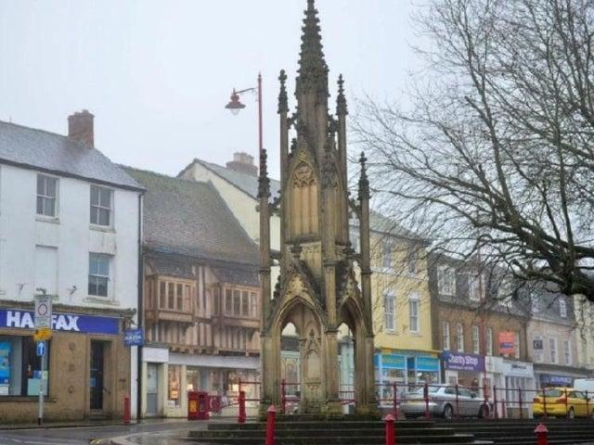

With this new-found reconnection, people can start working further away, within the county and in neighbouring county towns such as Banbury. This will improve the economy, but also attract more people to these beautiful towns and villages in the heart of the United Kingdom, as well as turn Northampton into an even better place, transforming the city centre, their high street, and of course, their transport scene. And allowing more efficient travelling to the city from other rural areas in the county.

We cannot finish this document without mentioning Northampton’s high street. There is nothing to attract it with, and instead, people are shopping in retail parks, and not on Northampton’s high street, which has the potential to be one of the country’s best city high streets, but that potential cannot be unleashed without this new transport link.

## 1e: To reconnect the surrounding counties

Of course, our primary focus continues to be locally within Northamptonshire, but with this project also comes a great opportunity: Link Northampton to Banbury and the Chiltern Railways Network.

This will be the main benefit for Northampton, to get a link to one of the hardest to access places via rail from Northamptonshire, Banbury, and the rest of the Chiltern Railways Network, such as Aylesbury and Oxford, which are also hard to access via rail from Northamptonshire, requiring multiple changes, including sometimes all the way down in London.

As well as this, a direct link to Leamington Spa will also be created, so people on this link such as in Daventry, Southam and of course, Northampton, can directly access Leamington Spa, an amazing town, which deserves links to Northampton, Southam and even Daventry.

Having a connection to Banbury and Leamington Spa does not mean onlyBanbury and Leamington Spa, it also means connections to other Chiltern Main Line served areas, such as Oxford and Aylesbury. This would boost the economy and allow students to study and get well-paying jobs in Oxford, while living in Northamptonshire.

## 1f: A link to the West Coast Main Line

Weedon Interchange will be one of the most important stations on the network for several reasons. It allows people to change from to and from the different branches and vice-versa, but most importantly, gives passengers access to the West Coast Main Line, arguably the most important railway line in the United Kingdom.

If the right operators stop at Weedon Interchange, it could introduce direct services as far as Glasgow and Edinburgh, but as close as London and Birmingham. The most likely thing to happen is London Northwestern Railway to stop at the station. However, Avanti West Coast, the “high-speed” Intercity operator may also stop at the station, for the one benefit that they will be able to connect Northamptonshire, not just the village of Weedon. If Avanti West Coast does stop at the station, it would mean fast services to and from Northamptonshire to places as far North as Edinburgh and Glasgow. If London Northwestern stops only, services will not go more North than Liverpool Lime Street, and more South than London Euston.

It is not only Towcester, Northampton, Weedon and more that could access the West Coast Main Line, but also Banbury and Leamington Spa, with simple access to one of the busiest railway lines in the world, and a first for these two towns, almost direct services to cities as North as Crewe and Liverpool, and maybe even Scotland.



# Environment

## 2a: Getting cars off the road

81% of people in the East Midlands have a car permanently available in their household and use it often, according to Statista Research Department. Out of this 81%, more than 6 billion miles were driven on Northamptonshire roads (DfT RTS.) We need to make these numbers lower, and to do that, more people could adopt rail as their primary way of travelling daily. However, the people of Northamptonshire are limited in doing that with the small number of railway stations in the county (six), and no links to their local town/village.

We can change that for South Northamptonshire and Daventry District residents by giving them a link to this fantastic infrastructure, and get them to use cars less often, in replacement of energy-efficient, electric transport.

If this line is built, less people will rely on their cars for their daily commute. I know a lot of people that live in Weedon and work in Daventry, even close family, that would be happy to give up the car in replacement for a train/BRT commute. This is also the same for people who live in Silverstone and work in Towcester, or even people who live in wonderful Leamington Spa and work in Northampton, who cannot even get there via rail without going up to Coventry and changing onto another train.

## 2b: The UK net-zero 2050 promise

If the UK wants to achieve net-zero by 2050, then they will have to make Northamptonshire an independent state, as we cannot get people out of cars without a replacement! Buses in Northamptonshire are quite bad, compared to other counties, with just the standard Stagecoach bus running. A great replacement would be sustainable and eco-friendly public transport, connecting South Northants and Daventry to the rest of the county, and nationwide rail network.

Cars are admittedly bad for the environment, but unfortunately, the East Midlands and most of the North rely on them for their daily commute. The British Government can change this by investing more in transport infrastructure such as this project, to help us rely on sustainable rail instead! The entire network will run on electricity, using no diesel on the link at all!

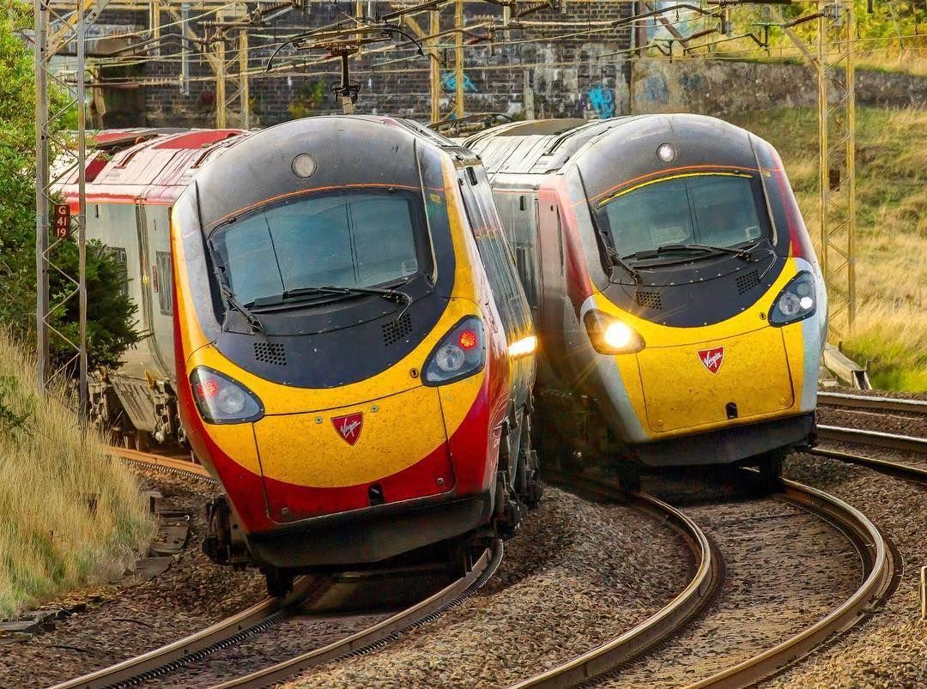

## 2c: Sustainable transport to our stations

Although we hope we can connect every large population centre in West Northamptonshire, and more, with this idea, sometimes no doubt some people will need to drive to the nearest station to them. Here are some things we are doing to encourage sustainable transport to these stations though:

* If people can walk, bike, or scooter to the station, including hire scooters/e-bikes, please do so as an alternative to cars.
* If people do decide to take a car and it is electric, please plug in at the stations! We will be implementing Charge + Ride services at all the stations on our route, so your car can charge during your journey.
* If available in your region, and you do not own a bike/scooter, please use a bike/scooter hire on demand service, available in places such as Northampton, Kettering, and possibly Daventry in the future. It will help more than you think it will!

At our car parks, we will follow these rules:

* **No** multi-story car parks
* **All** car parks must have EV chargers installed
* **No** car parking in village stops
* **Bus stops** accessible in the car park



# Misc.

## 3a: Issues with our existing infrastructure

More than 6 billion miles of road was driven on within Northamptonshire in 2019. This is a lot of miles. Enough to get around the Earth more than 225,000 times. For a country that wants to get to net-zero emissions by 2050, this is not a good sign. More sustainable transport methods are required if we want to meet that goal.

Not only this, but rail is a lot safer than private car to use, with less casualties a year, and more safety systems than a common, traditional car would. 1,784 people sadly died while using cars throughout 2018. More than 150,000 injuries were reported in 2018 too, 25,000 of high severity.

5 deaths occur due to car accidents per day (2013 ONS data), compared to 7 passenger deaths on trains in the entirety of 2013, and an average of 329 Public rail fatalities a year (on the tracks), accounting around 0.9 average per day in 2018-19 On trams and light rail, 12 fatalities of members of the public were recorded in the entirety of the 2018-19 period, making it hard to even divide.

Traffic is an entirely different issue: in all types of towns in Northamptonshire, traffic is a problem. In Towcester, many traffic issues occur, being a hub for many A-roads in Northamptonshire including the A5 and A43. As well as this, Towcester is also a central hub for many other types of things such as a busy school, and the Admin HQ of the South Northamptonshire Council, the council that covers the towns of Towcester and Brackley and the surrounding large villages.

Roads are not the only problem, with bus connections to places such as South Northants from Daventry being non-existent, requiring a long, boring change in Northampton. A new system needs to be developed to remove these issues from Northamptonshire’s bus network.

Pedestrian access to transport in Northamptonshire, and more specifically, Daventry/West Northants Council Areas, is not too good and up to standard. The three stations in the West Northants area include Long Buckby, Kings Sutton and of course, Northampton. Only one out of two has sufficient accessibility. Access to Kings Sutton’s London-bound platform is not possible without using a railway bridge, and access to Long Buckby platform 2 is not possible without using quite a dodgy tunnel and stairs.

We need a fresh start in accessibility. A new transport link would be just the answer.

Below: Long Buckby station platform access; the nearest station to Daventry

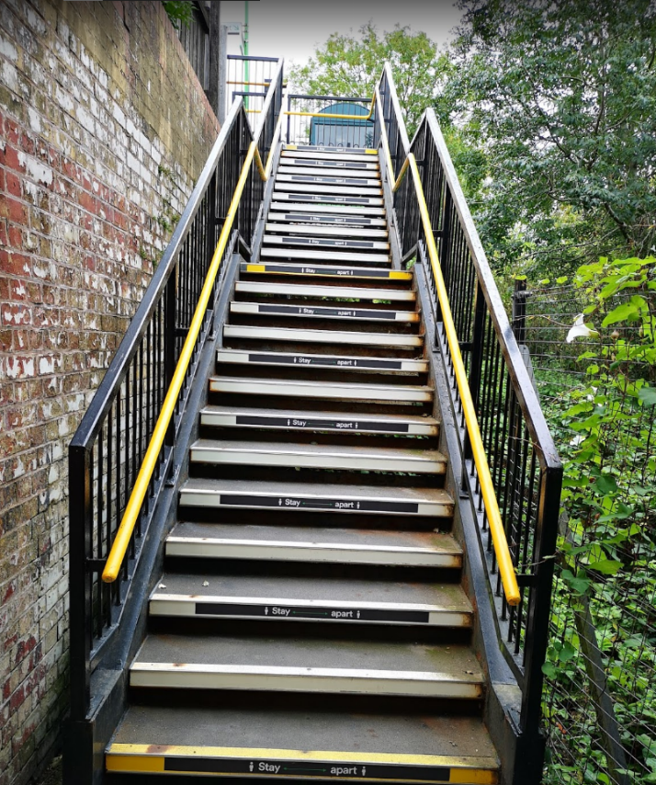

## 3b: Daventry-sized towns with rail links

Towns such as Buxton, Alton, Stamford, and even Faversham in Kent have rail links. However, Daventry, a larger town than those listed, are stuck with buses, no rail of any sort. In this section, we will analyse these other areas rail link, and see how they have benefitted from it.

Let us focus on Faversham, a station with a major stop on the Chatham Main Line. Approx. 20,000 people live in the town of Faversham, and 1.5 million entries and exits were made from their station, that is around 4500 approx. entries and exits a day.

You can just imagine how this station can benefit the local economy, allowing direct London Victoria and St Pancras International services, and Dover Priory services, some of the largest hubs in the country. Partly because of this station, the value of Swale's visitor economy grew by 3.9% in 2017 and is now worth £237 (Swale is the borough which Faversham is a part of.) The entirety of Kent’s visitor economy is stood at a hefty £3.8bn in 2017 too.

Rail is not the only transport link in Faversham. Bus companies including Arriva Southern Counties, which runs service 333 to Sittingbourne and Stagecoach in East Kent operates routes 3,3X,3A,3B to Canterbury, and route 666 to Ashford. However, Swale Borough Council have expressed concern over the lack of bus and cycle facilities in the town, when compared to road and rail, and there is a particular lack of public transport to nearby rural areas.

## 3c: Land use

Land take – HS1 vs Lower Thames crossing motorway (Highways England)

According to Highways England, the organisation campaigning and eventually building the Lower Thames Crossing:

“Our forecasts predict that a new crossing at Location C in its opening year in 2025 would carry 78,500 vehicles per day and would reduce traffic at the Dartford Crossing by 14%. When added to the existing Dartford Crossing, total capacity across the Thames would increase by approximately 70% (as shown in the map above).” The crossing will be 16 metres wide. The tunnels will be some of the largest bored tunnels in the world.

Now comparing to HS1, it carries 26 million passengers a year, including international and domestic services. This accounts to 75,000 people per day, of which 41,000 are domestic Southeastern services to and from St Pancras International. HS1 is around 13 metres wide. This data was taken at Rainham, and continues to be 13m wide, give or take, most of the route depending on if it is a two track or four track railway at the specific point.

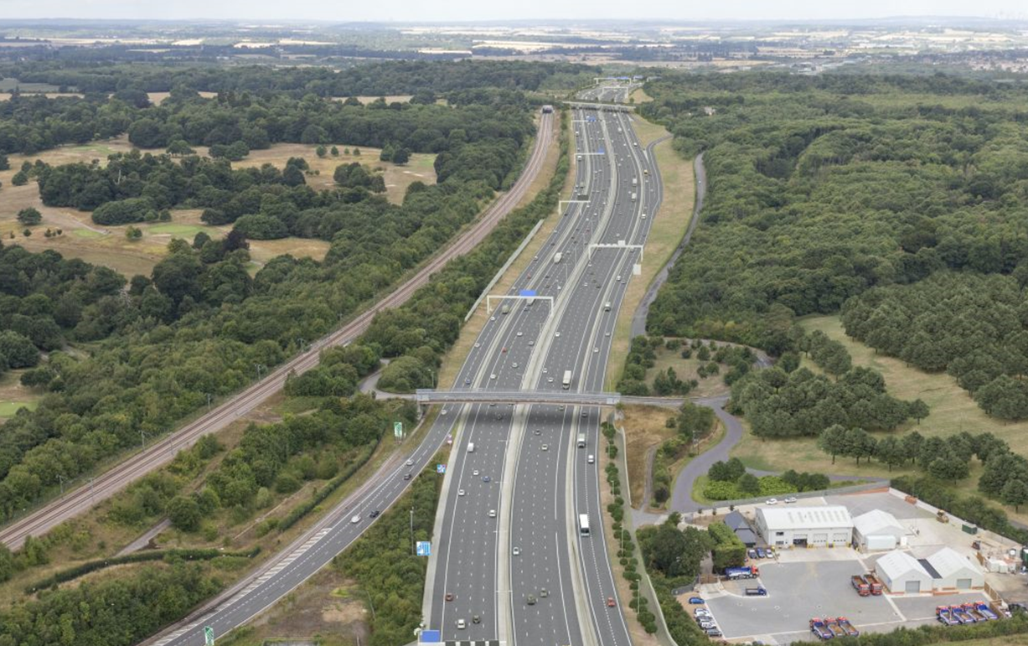



# A solution

## 4a: Heavy rail

The first idea I had was for a heavy rail version of South Northants Link, the debatably fastest way of getting from A to B locally.

**Heavy Rail** is located in **Appendix A** of the South Northants Link library of documents. Download it here:

[https://snl.crd.co/#reports](https://snl.crd.co/%23reports)

## 4b: Light rail

**Light Rail** is located in **Appendix B** of the South Northants Link library of documents. Download it here:

[https://snl.crd.co/#reports](https://snl.crd.co/%23reports)

## 4c: Tram-train

**Tram-train** is located in **Appendix C** of the South Northants Link library of documents. Download it here:

[https://snl.crd.co/#reports](https://snl.crd.co/%23reports)

## 4b: Bus-rapid-transit (BRT)

**Bus-rapid-transit (BRT)** is located in **Appendix D** of the South Northants Link library of documents. Download it here:

[https://snl.crd.co/#reports](https://snl.crd.co/%23reports)